Module (css and css 3)-2

1.What are the benefits of using CSS?

1. Faster page speed

2. Better user experience

3. Easy formatting changes

4. Compatibility across devices

2. What are the disadvantages of CSS?

1. CSS website security is a main drawback.

2. There are many such features in css which do not support all browsers.

There are many versions of CSS and different features of all the versions which confuse the beginner and the developer a lot.

3. What is the difference between CSS2 and CSS3?

* In CSS2, everything is present in a single document while CSS3 is categorized into multiple sections called modules.
* Graphics-related features such as Box-shadow or Border-radius, flexbox, etc. can be found which are absent in case of CSS2.
* Properties such as background-position, background-image, and background-repeat styles can be helpful for using multiple background images in a single webpage.
* CSS3 versions support many new browsers.
* CSS3 introduces many new selectors in the form of pseudo-elements and pseudo-classes

4. Name a few CSS style components,

A few CSS style components include Property, Value, and Selector.

5. What do you understand by CSS opacity?

The technical definition of opacity is the degree to which light is allowed to pass through an object. CSS opacity is the property used to describe the transparency of an element. In other words, it explains how clear the image is.

6. How can the background color of an element be changed?

The background color of an image can be changed using the background-color property.

body{

background-color: red;

}

7. How can image repetition of the backup be controlled?

Background-repetition property controls the repetition of images in the background. Use no-repeat if the image is to be displayed once in the background.

{

background-image: url(hbhvhgv);

background-repeat: repeat;

}

8. What is the use of the background-position property?

It can be used to define the initial position of a background image. The default position is the top left of the page. The positions that can be set include top, bottom, left, right, and center.

{

background-position: center;

}

9. Which property controls the image scroll in the background?

Image scroll in the background can be controlled using the background-scroll property.

10. Why should background and color be used as separate properties?

This is done with mainly two purposes:

* It makes the style sheets more legible. Background property, which is complex in itself, becomes all the more complex with color.
* Color is an in-built property while the background is not one. And this can lead to a lot of confusion.

11. How to center block elements using CSS1?

In order to center the block-level elements, we need to set the margin-right and margin-left properties to explicit values.

12. How to maintain the CSS specifications?

To maintain css specifications use valid syntax, text across

browser and stay updated with changes.

Example: validate code with W3C.

13. What are the ways to integrate CSS as a web page?

There are three methods to integrate CSS in the form of a web page:

* **Embedded:**There can be a style element inside the head element inside which we can place the code.
* **Inline:** CSS can be applied directly to HTML elements using attributes.
* **Imported or Linked:**In the case of linked or imported CSS, the CSS is placed in an external file and a link element is used to link it.

14. What is embedded style sheets?

These are the sheets where style sets for the entire HTML document are defined in a single place. For doing this, the style sheet information under the style tags should be embedded into an HTML document.

15. What are the external style sheets?

External style sheets are sheets used externally which can be linked to the HTML pages.

Example.

<link rel="stylesheet" href="mystyle.css">

16. What are the advantages and disadvantages of using external style sheets?

* There can be many documents for multiple HTML elements, along with many classes.
* Multiple documents with various styles can be controlled using different styles.
* Selector and grouping methods can be used for grouping styles in composite situations.

**Disadvantages:**

* For rendering the document, external style sheets have to be loaded.
* It is not suitable for small style definitions.
* For importing documents with style information, an additional download is required.

17. What is the meaning of the CSS selector?

**CSS selectors** are used *to select the content you want to style*. Selectors are the part of CSS rule set. CSS selectors select HTML elements according to its id, class, type, attribute etc.

EXMPLE.

1. CSS Element Selector{

<p> </p>

<h1> </h1>

}

1. CSS Id Selector

<p id=”name”> hello</p>

.example.

#name{

#para1 {

    text-align: center;

    color: blue;  }

1. CSS Class Selecto

Example.

1. **<h1** class="center"**>** hello **</h1>**
2. **<p** class="center"**>**hello**</p>**

.center {

    text-align: center;

    color: blue;  }

4.CSS Universal Selector

Example.

**1. <p>**hello.**</p>**

**2. <p** id="main"**>**hii**</p>**

* {

 color: green;

  font-size: 20px; }

18. What are the media types allowed by CSS?

There are four types of media properties:

* **All for all media type devices**
* **Print**for printers
* **Search for screen readers that “read” pages out loud**
* **Screen for computer screens, tablets, mobile phones, etc.**

EXAMPLE:

320px — 480px: Mobile devices.

481px — 768px: iPads, Tablets.

769px — 1024px: Small screens, laptops.

1025px — 1200px: Desktops, large screens.

1201px and more — extra large screens, TV

19. What is the rule set?

Rulesets can be used to identify selectors attached to one another. It consists of two different parts - selector and declaration.

20.Create Layouts

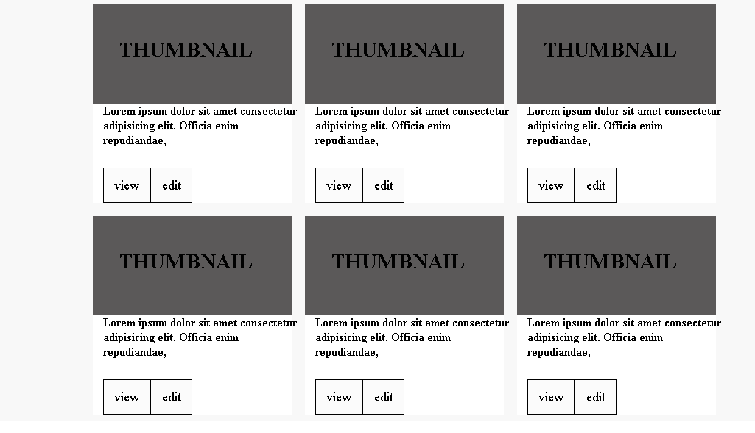

Example:

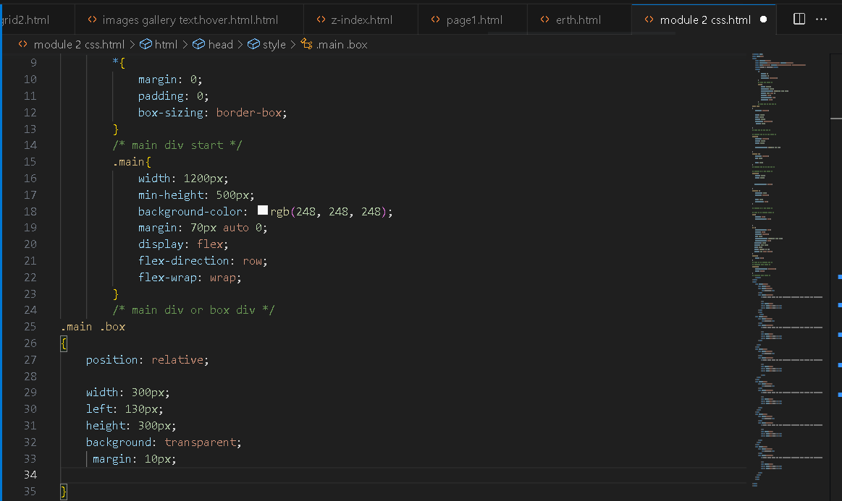

2. 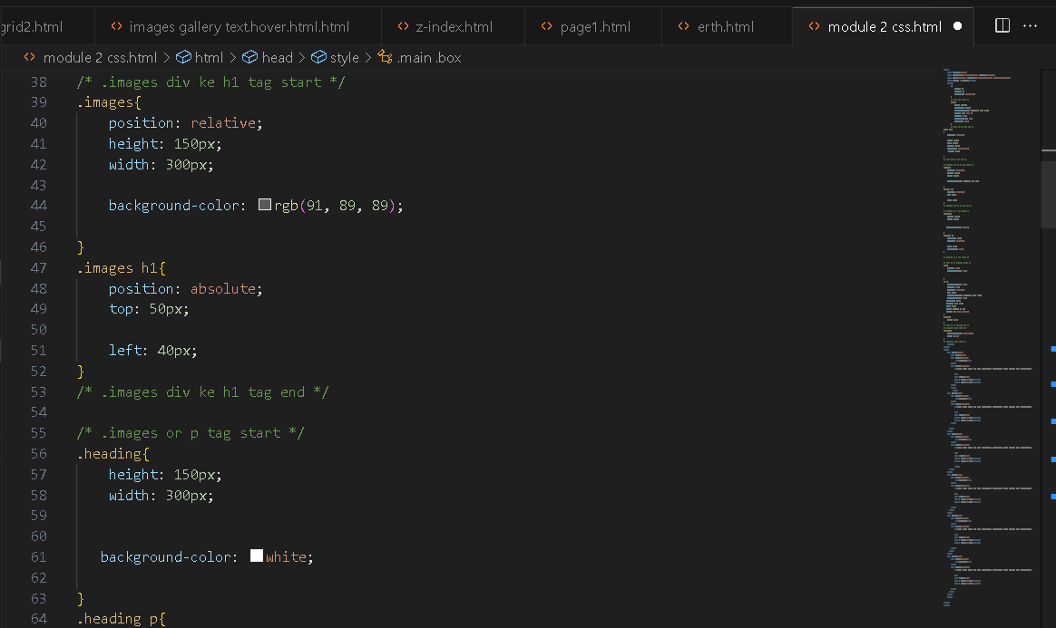

3. 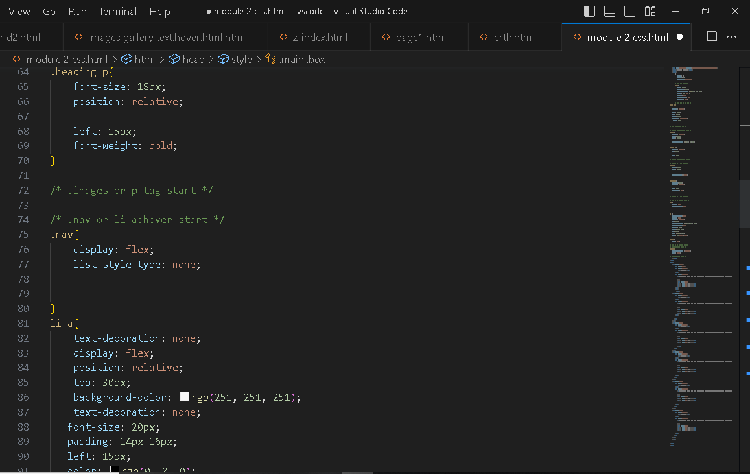

4. 